**Sales Analysis Segments:**

***Product Analysis***

1. *Get general overview of where all branches are located*

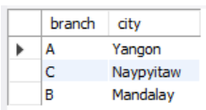

1. *What are the unique products sold?*

|  |
| --- |
| Food and beverages |
| Health and beauty |
| Sports and travel |
| Fashion accessories |
| Home and lifestyle |
| Electronic accessories |
|  |

1. *How do the products perform?*

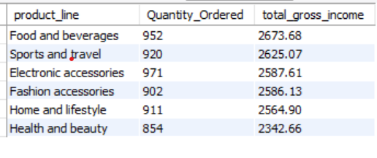

***Sales Analysis***

1. What are the sales by city?

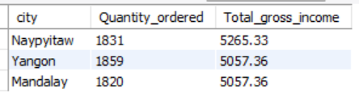

1. What are the sales by payment method?

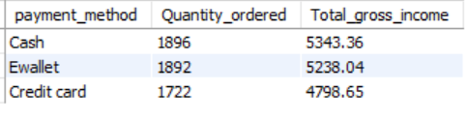

1. What are the sales by branch?

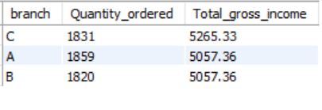

1. When (day) are the sales at their pick, and at the lowest point?

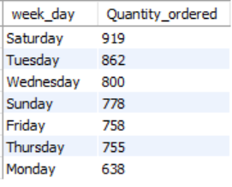

1. What are the sales by time of day?

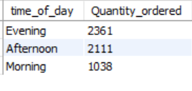

1. What are the sales by hour?

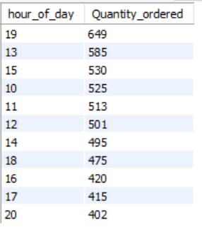

***Customer Analysis***

1. What are the sales by gender?

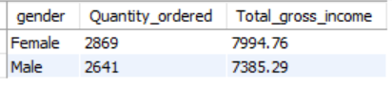

1. What are the sales by customer type?

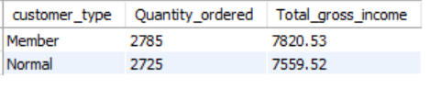

1. What are the customer ratings by city?

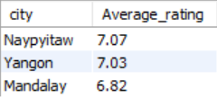

1. What are the customer ratings by payment method?

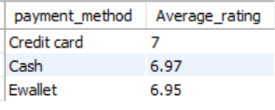

1. What are the customer ratings by product line?

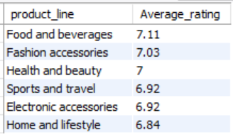

1. What is the customer rating by gender?

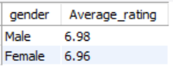

1. What is the customer rating by branch?

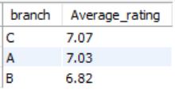

1. What is the customer rating by customer type?

